***EXPERIMENT 4***

**OBJECTIVE**

To draw the phasor diagram of series RLC circuit and compare the experimental and theoretical results.

**Equipments required:**

Signal Generator, DSO, Multimeter, Components, Bread board

**Procedure:**

1. In practical circuits, we do not have pure inductances since the wire used in the winding presents some resistance. Hence the practical inductor is not a pure inductance represented by a 90° phase angle, and thus VL (drawn in the phasor diagram) is at an angle slightly less than 90°. The phasor diagram of the series RLC circuit is as shown in fig 1.
2. To get the actual phase angle of the inductor, Measure the DC resistance of the inductance coil separately and use the given formula.
3. Now connect the circuit as shown in circuit diagram.
4. For a particular value of sinusoidal input voltage, measure the voltages across the individual elements using DSO.
5. Repeat the above experiment for a number of input voltage values (voltage should be less than 1V) and at different frequencies.
6. The amplitude of the source voltage across all three components in a series RLC circuit is made up of the three individual component voltages, VR, VL and VC with the current common to all three components. The vector diagrams will, therefore, have the current vector as their reference with the three voltage vectors being plotted concerning this reference (current).
7. Note down the component Values
8. R= 2000 Ω
9. L= 2 H
10. C= 11 nF
11. r = 80.2 Ω
12. Fill the table using DSO waveforms at different frequencies

V(Volt) VR(Volt) VC(Volt) Vr(Volt) I(Amp)=VR/R

1. Make Phasor diagram using measured values and theoretical values and compare the result.

Notice if

1.Electrical resistance - Resistance is independent of frequency, so it remains constant with change in frequency.

2.Inductive reactance, XL - We know that XL = 2πfL so, inductive reactance varies directly with frequency.

3.Capacitive reactance, XC - From the formula of capacitive reactance, XC = 1/2πfC so, capacitive reactance varies inversely with frequency.

Circuit diagram

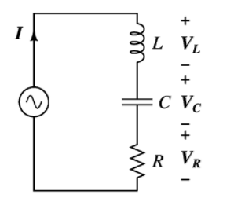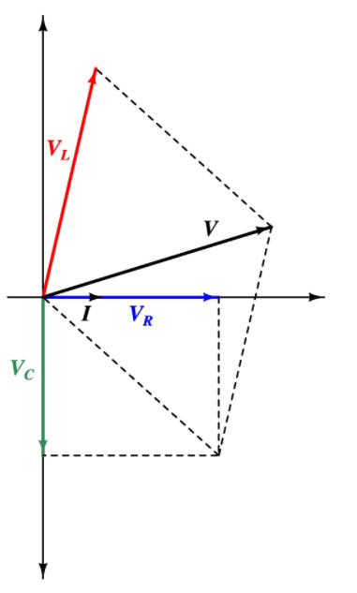

Fig. 1

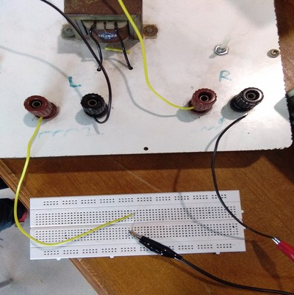

Snapshot of the breadboard with components connected as shown in the circuit diagram

**Observation:**

|  |  |  |  |  |  |
| --- | --- | --- | --- | --- | --- |
| **Frequency (KHz)** | **Vmax (V)** | **VR (V)** | **VL (V)** | **VC (V)** | **I (A)** |
| 1 | 1 | 0.32 | 1.84 | 2.36 | 0.00016 |
| 2 | 1 | 0.134 | 1.35 | 0.496 | 0.000067 |
| 1 | 2 | 0.608 | 3.62 | 4.56 | 0.000304 |
| 2 | 2 | 0.252 | 2.6 | 0.944 | 0.000126 |

Snaps of DSO:

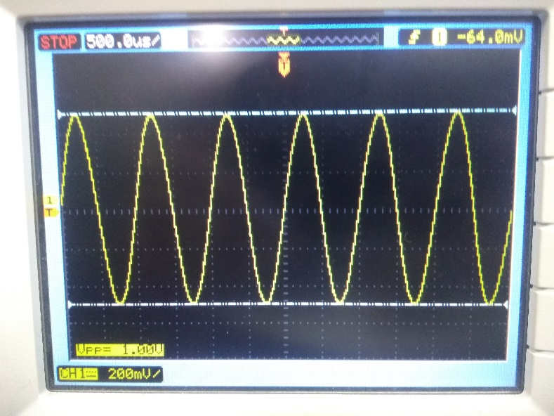

Input Waveform (1 V)

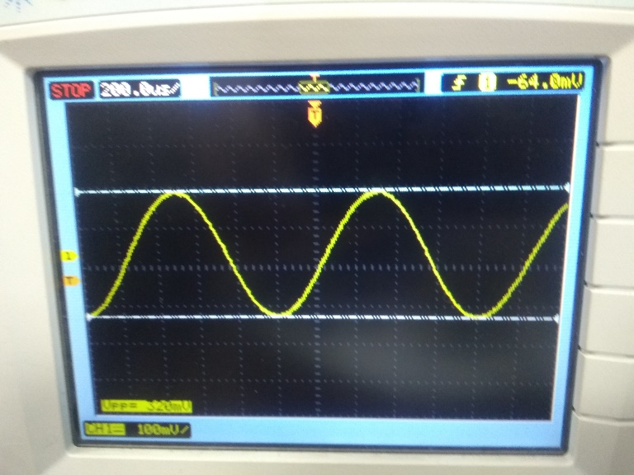

VR (1 KHz)

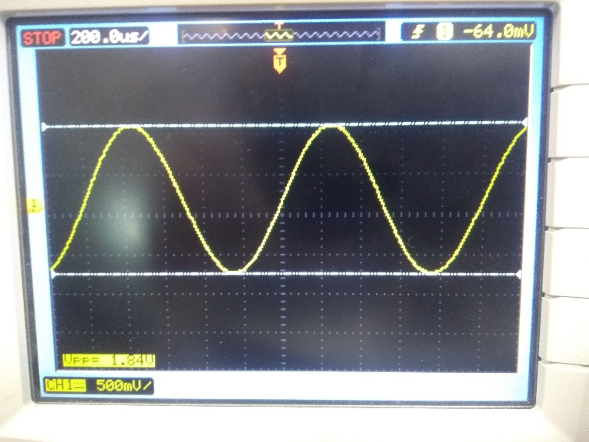

VL (1 KHz)

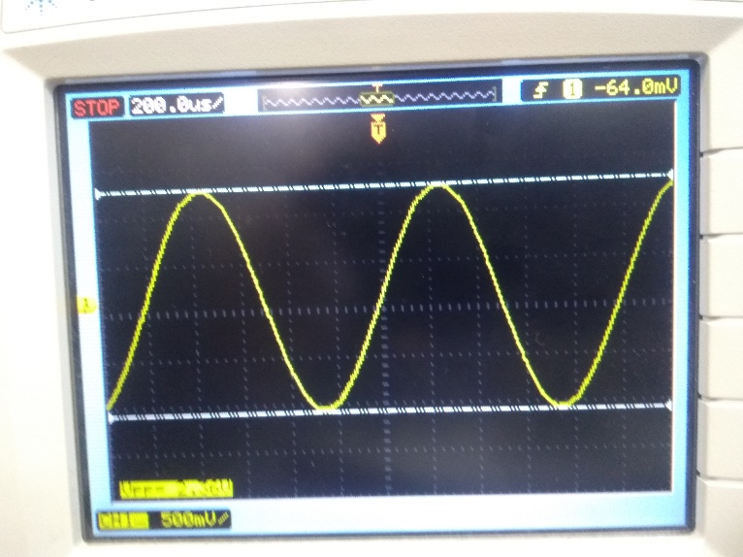

VC (1 KHz)

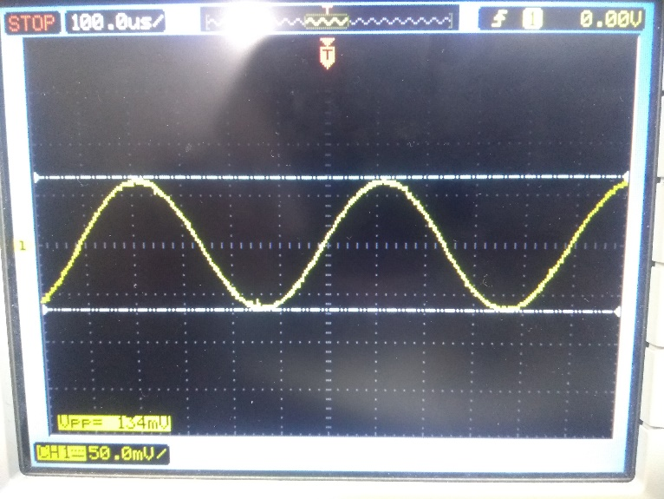

VR (2 KHz)

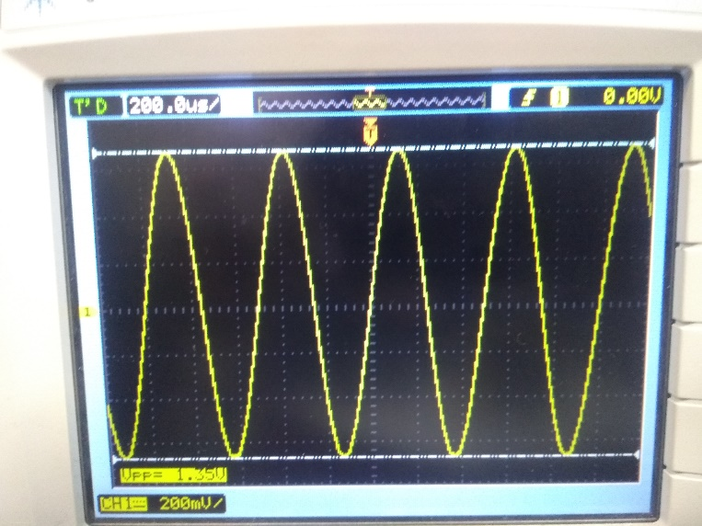

VL (2 KHz)

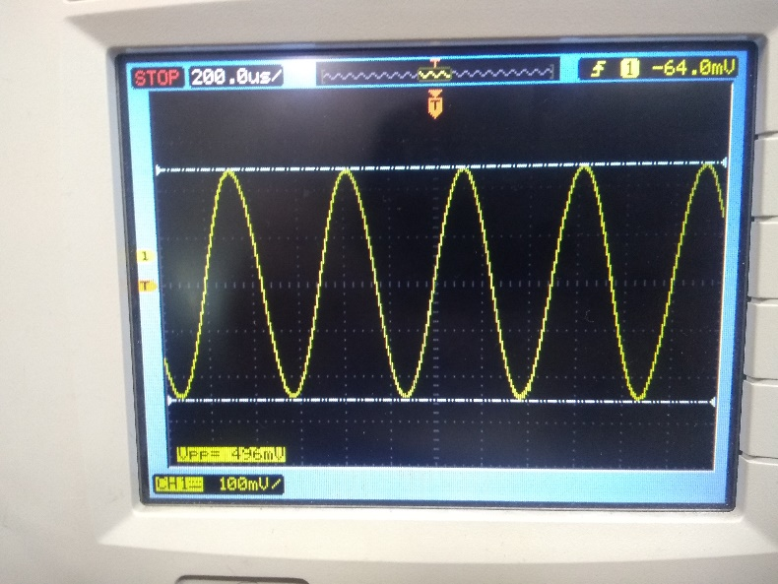

VC (2 KHz)

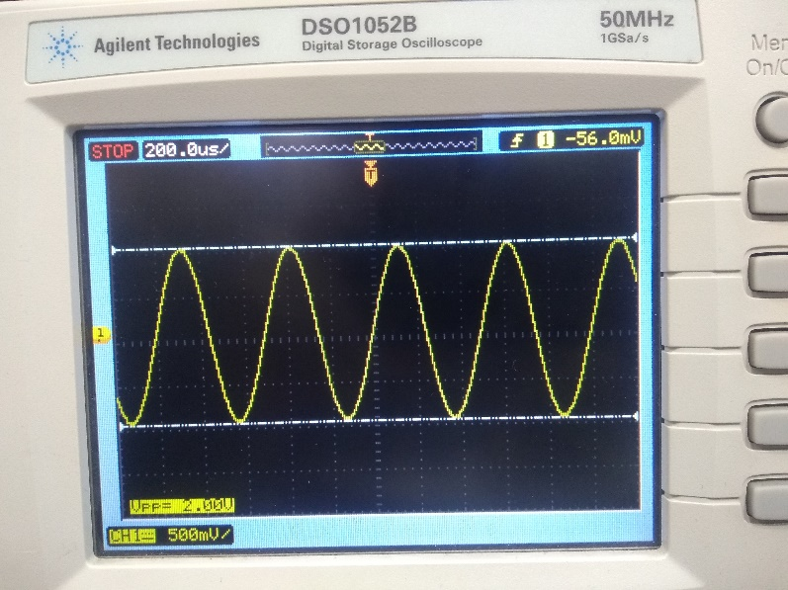

Input Waveform (2 V)

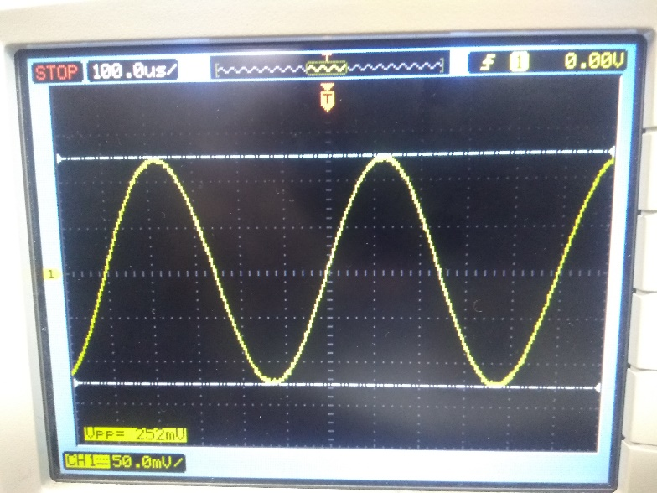

VR (2 KHz)

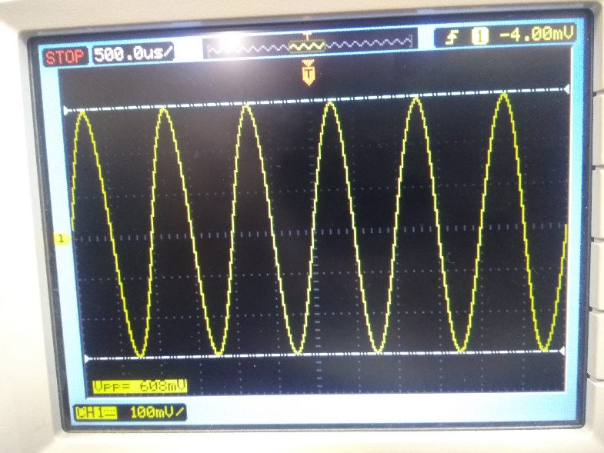

VR (1 KHz)

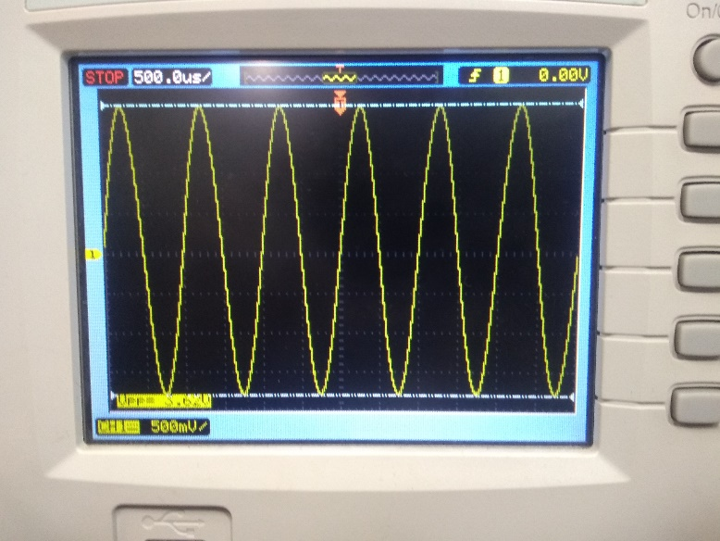

VL (1 KHz)

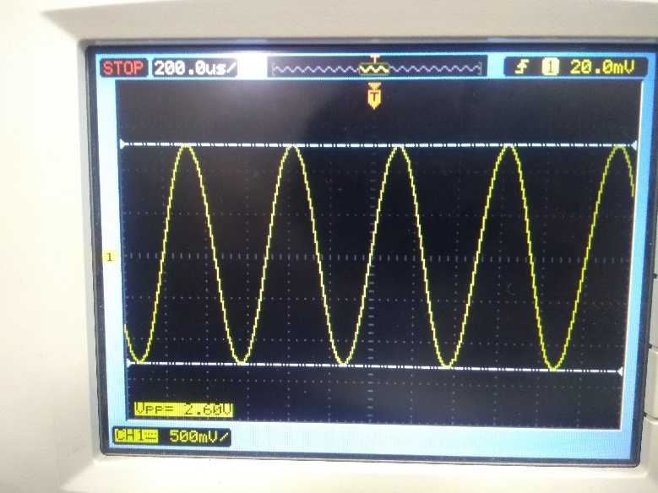

VL (2 KHz)

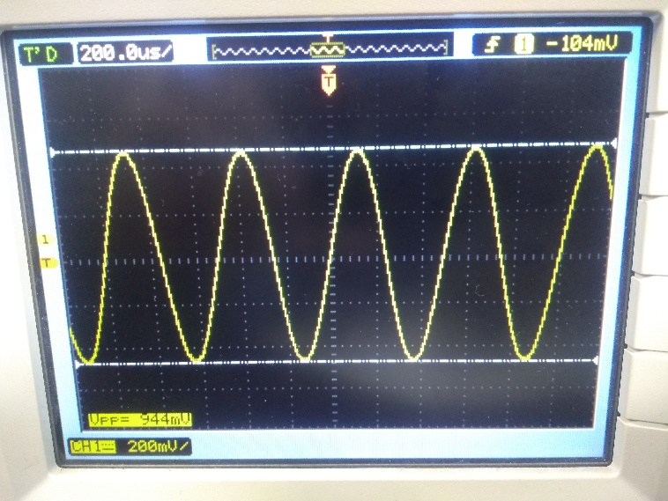

VC (2 KHz)

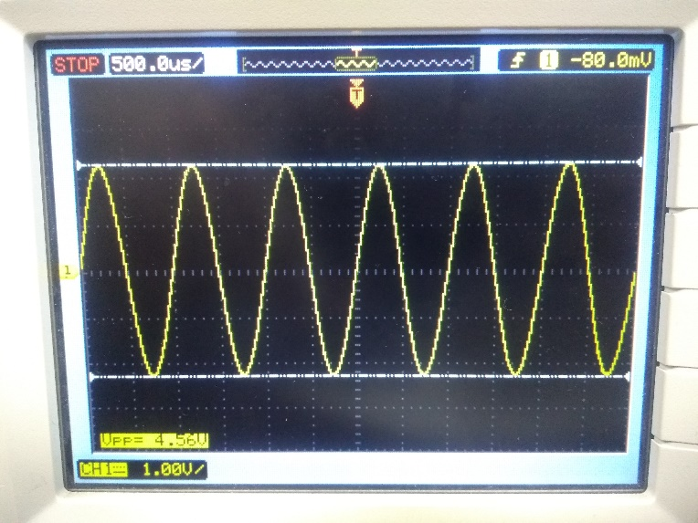

VC (1 KHz)

**Conclusion:**

In this experiment, we observed the response of the electrical circuit to sinusoidal excitations. First, all of we connected the setup of RLC series circuit, and then we applied the input through function generator and then noted down the various voltage drops across all elements, namely resistor, inductor, and capacitor. And then we tried to verify the readings by equating vector sum of voltages of VL, VR, and VC with the total voltage applied. But we realized, and it came to our vision that solving the RLC circuits through the help of phasor diagrams is far simpler than solving it analytically (quite a rigorous method).

Hence, we made phasor diagrams to visualize our circuit more efficiently.

During the experiment, there were some errors encountered that may be due to human reading, manipulation error, etc. We need to be cautious as the results may be contrary to what is expected. So, we also took the resistance of inductor into account. Thus, this experiment helped me to practically verify the results obtained in AC series RLC circuit and observe the sinusoidal response in the form of waveforms obtained on DSO.